# Afro Shamans and Madini Moyoni Strategic Investment Proposal

Copper Mining Project, Mbesa, Tanzania

April 2025



MADINI MOYONI

TZ

-

UK CONSORTIUM

PUTTING HEART INTO

MINERALS

1

Version 1.0A - 31 January 2024

April 2025

# Contents page

|  |  |  |
| --- | --- | --- |
| Introduction | 3 |  |
| Background | 4 |  |
| Meet the Team   * Afro Shamans * Madini Moyoni * Our Advisers | 5  6  7 |  |
| Challenges the team have faced | 8 |  |
| Turning challenge into opportunity | 9 |  |
| Our Vision | 10 |  |
| Profitability meets purpose | 11 |  |
| Our mine site | 12 |  |
| Approach | 13 |  |
| Impact of your investment | 14 |  |
| What's in it for you? - ROI for investors | 15 |  |
| What you get for your investment | 16 |  |
| Join Us | 17 |  |
| Our Website | 18 |  |
| Appendices   * I – Financial projects & Market Capitalisation * II – Investment Breakdown * III – High Levels Risks * VI – ESG (Environmental, Social, Governance) Road map |  | 2 |

April 2025

# Introduction

Our mining project will give artisanal miners, located on the copper belt, in rural Africa the opportunity to better themselves, their families and their communities by mechanising and up-scaling their operation and applying professional business management to it. We want to do this sustainably and safely, whilst preserving and enhancing the environment. We will elevate the local population and impact them positively in social, economic and ecological terms.

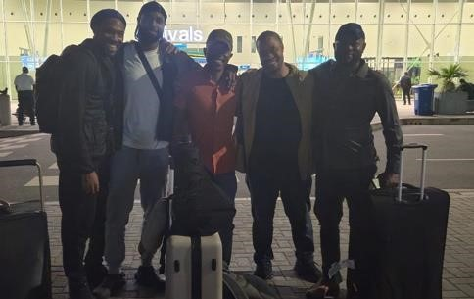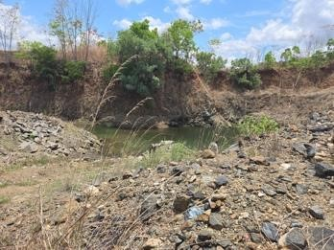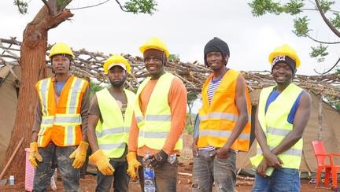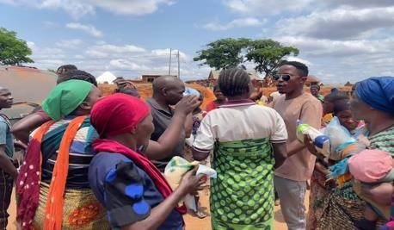

What makes our approach special is that at the same time as providing exceptional benefits to the workers and their community, we will run a successful, growing and profitable business for generations to come. We will apply modern techniques and business models that can be replicated across the region, the country and, we believe the continent. We will operate as a beacon of responsibility, professionalism and fairness, in what is usually an exploitative, unprofessional and unsafe working environment.

Our investors will have a unique opportunity to help an entire community to grow and prosper. They will experience the impact that their investment has on people and be able to get involved personally.

We have a bold vision of creating a paradigm shift where Africa finally reaps the benefits of refining its own materials e.g. copper cathodes and bars rather than just ores/raw materials. Our intention is to build a replicable, circular economy where significant portions of profits are reinvested into building processing plants, expanding our community outreach projects, developing local infrastructure, roads, schools and hospitals and creating jobs and opportunities for local people and business.

3

April 2025

# Background

Afro Shamans Company Ltd (ASCL), based in Mbesa in southern Tanzania, are an extended family business which has been working with local communities to improve their social and economic prospects through businesses that they create and run, including both commercial and social projects. They have spent many years working on multiple projects, including mining natural resources.

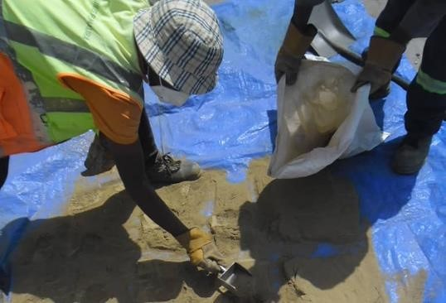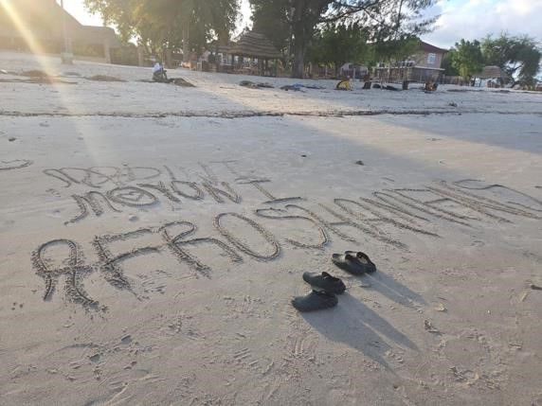

Getting a fair price for their precious metals and minerals is just one way that they are changing things for the better for Tanzanian local communities. They need two things happen to accelerate their mining ventures: Access to international markets and funding for machinery and mine-site set-up.

When initially working with ASCL to broker deals on copper, gold and silver with international buyers two years ago, MML realised that with a relatively small investment in mining terms, it will be possible to deliver extraordinary returns and to make massive improvements to the lifestyle and well-being of the local artisanal mining community.

This is why the joint venture with UK-based Madini Moyoni (MML) was created. MML directors have worked for years to support businesses and government officials in African countries to build businesses and establish international connections.

Our exclusive joint venture will allow ASCL to fully exploit the abundant resources to which they have access, and to sell the precious metals on the international market for a good price. Together with your investment we will bring amazing benefits to the rural population.

The following slides give more information on the people involved in our joint venture

# Madini Moyon i Afro Shamans Company Limited



Afro Shamans are social engineers, community activists/philanthropists who are passionate about mining and minerals. They have been operating for over 20 years as artisanal miners with around 25-30 core members who are family either directly connected by blood or lifelong ndugus (brethren’s) connected by faith and spirituality.

The Mshana family are descendants of the Shana clan, who were traditionally known as blacksmiths of the Ugweno tribe. Their

ancestral home is in the Pare Mountains in the Kilimanjaro region.

## **ROSAN MBWAMBO**

**CHAIRMAN/CEO**

Rosan has over 20 years of legal experience, specialising in arbitration at national and international level, mining, construction, labour law. As Chairman, Rosan is responsible for overseeing and approving crucial contracts, legal documents, and frameworks. His wealth of experience and knowledge will undoubtedly be invaluable in ensuring the project's success.

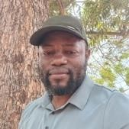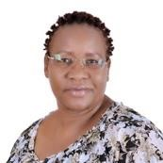

**ELLY MSHANA**

**CHIEF EXECUTIVE OFFICER**

Elly is a devout Christian minister offering counseling and spiritual guidance to rural communities in Tanzania. He has over 30 years in mineral exploration and heavy machinery operations across East

Africa, including DRC,

Zambia, and Mozambique. Elly is the mining guru of

Afro Shamans, passing on his extensive knowledge to his brothers and team.

## **SAMSON MSHANA**

**CHIEF OPERATING OFFICER**

Sam learned mining from older brothers Elly and Emmanuel during gemstone and precious metal expeditions. He combined practical experience with independent studies in geology and geophysics, becoming our mineral expert. And has travelled across Tanzania deepening his regional knowledge and identifying prime mineral locations.

## **EMMANUEL MSHANA**

**HEAD OF STRATEGY**

Emanuel is Head of strategy and CSR at Afro Shamans, with extensive experience in community empowerment. He is the co-founder of Pamoja Afrika, driving impactful projects in rural Tanzania. He has set up a number of key initiatives including sustainable farming, clean water access, sanitation, and creating educational and career opportunities for local communities.

## **DORIS MBWAMBO**

**HR DIRECTOR**

Doris is Managing

Director and part owner of DRREC Limited and Blossom Kids Hub. She is an experienced lawyer skilled in HR, training, policy revision, and compliance management. Doris successfully manages multiple ventures, including catering and childcare centers, employing hundreds.

|  |
| --- |
| Amani Blass Saleko is the head of mining site who oversees the production of copper, health and safety and quality assurance processes. He has managed a number of mining sites across Tanzania and as a lifelong ndugu (brethren) of the Mshana family hailing from the same region, Kilimanjaro. He also owns a hotel in his home town of Moshi and is a community activist who has built school facilities for local children. |

5

**AMANI BLASS SALEKO**

**HEAD OF MINE SITE**

 April 2025 Madini Moyoni Ltd 2025

## Madini Moyoni

ADRIAN MAILE CARSUE CURNIFFE DANIEL SMITH SOLOMON AMOS JEREMY HENDERSON

### CHAIRMAN/CEO

Adrian has over forty years’ business

experience in a range of senior executive

positions in global companies and in running his own

consulting and family businesses. He has worked across all

industry sectors with a special focus on

Emerging Markets, including Africa.

As Chairman/CEO of Madini Moyoni, Adrian is responsible for the company's strategic direction, providing

leadership and fostering relationships with

investors, shareholders and regulatory bodies.

### CHIEF OPERATING OFFICER

Carsue has over twenty years’ experience as a

business change and PPM consultant leading

complex, transformation

projects and procuring and managing multi-millionpound contracts. He is

passionate about working in Africa and other

emerging markets and

creating a legacy of socioeconomic change. As a founder and C.O.O of Madini Moyoni, Carsue has beeninstrumental in creating the vision,

strategy and laying the foundations for this

ambitious project to be a success.

### CHIEF REVENUE OFFICER

Daniel is an expert in procurement and managing supplier relationships with over 20 years of

experience. A skilled

negotiator, he has a proven track record of securing

multi-million-dollar deals on behalf of clients across Europe, the Far East,

America, and Africa.

Through his exceptional communication and

collaboration skills, he has

fostered mutually beneficial partnerships and achieved

remarkable revenue growth for the companies he has worked with.

### CHIEF TECHNOLOGY OFFICER

Solomon has over 15 years of expertise in the IT

sector, specialising in system management and leveraging emerging technologies to

revolutionise business operations.

As the CTO for Madini

Moyini, Solomon will implement Smarter working solutions and harness the full potential of technology to gain a competitive edge in today's rapidly evolving digital landscape.

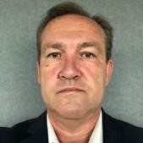

### CHIEF FINANCIAL OFFICER

Jeremy is a chartered accountant with over a decade of commercial finance experience,

having originally qualified with Baker Tilly and then worked as a manager for

PricewaterhouseCoopers in Barbados.

As Chief Financial Officer he is responsible for

managing the group’s finances, ensuring

complete transparency

and integrity all the way from investment and structure through to

monthly reporting, cash flow management, and

ensuring robust financial controls.

## Our Advisors

### **STANLEY I. ETKIND ANNA TIBAIJUKA ASAMOAH MFOAFO NOVATH MSANYA**

**INTERNATIONAL ADVISER POLITICAL ADVISER INTERNATIONAL ADVISER CUSTOMS CLEARING AGENT**

Stan provides and links Anna Kajumulo Tibaijuka, Asamoah Mfoafo, from Novath Msanya - Afro traders, buyers and former Tanzanian politician Ghana, is the person Shamans’ childhood friend

sellers in international and United Nations official, responsible for bringing is our customs clearing commerce. He has was member of the National agent at Dar Es Salaam brought many Assembly for Muleba South the UK and Tanzanian port and Madini Moyoni's

innovations to South constituency during 2010 to partnership together in adviser on all aspects of Africa by providing his 2020 and served as the the beginning. He has a logistics expertise to significant Minister of Lands, Housing vast network of contacts He has been instrumental



undertakings. With years and Human Settlement and wide business in supporting our trial

of dedicated service, Developments from 2010 to experience in Africa. He delivery, due to his

Stan has built up strong 2014. Anna is also a former holds a degree in knowledge and expertise in relationships across Under-Secretary-General of Microbiology, all apects of transportation

multiple continents the United Nations and Immunology and and shipping. globally. Stan’s executive director of the Molecular Biology and is

experience and personal United Nations Human

relationships with the top Settlements Programme a consultant in financial echelon of the (UN-HABITAT). She was and operational markets.

government of China, the second highest ranking

dating back to 1993, African woman in the UN. offers invaluable advice

in working with clients on the Asian continent.

Madini Moyon i

#### GARETH EVANS

##### TECHNICAL ADVISER

Gareth is Chairman of

Lancashire Machinery

Services Limited UK -

(LMS UK) which sells both used and new

mining, construction, and agricultural machinery

worldwide. Registered in the UK, Gareth has

decades of experience working in the mining

sector across the African

continent on thousands of projects. His knowledge

and experience of what it takes to run a successful mining operation will be invaluable to this

ambitious project.

7

April 2025 Madini Moyoni Ltd 2025

## Challenges the team have faced

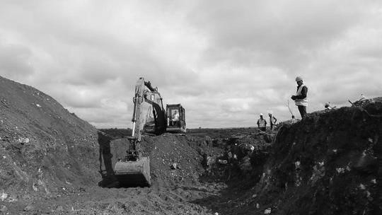

. Licences

5

2

. Equipment



. H&S

6

7

. Data

. Royalties

3

4

. Off

-

takers

Large mining concessions can

pinpoint the best places to mine,

whereas those working in the

ASM sector often have to guess

and use trial and error to find

deposits, which typically results in

low yields, loss of investment and

increased environmental

degradation.

Over 1.5 million Tanzanians depend on

mining, yet 80% work in unregulated,

hazardous conditions with n

on

-

existent

safety and labour standards.

Paying Royalties

-

Even if an ASM

has access to machinery, then paying

export tax and government royalty

fees is the next barrier and often a

deal breaker for many ASM’s.

The major knock

-

on effect of lack of

finance is that ASM miners often do not

have the equipment or facilities to be able

to mine at a scale that would be profitable

for them. Many ASM communities mine by

hand with rudimentary, manual tools.

. Capital

1

Debt and poverty are major concerns in ASM.

Informal work means miners cannot access traditional

sources of finance. This stops enterprises from

operating before they start because a certain level of

capitalisation is required to register and gain a mining

concession

**Our only barrier is getting the**

**capital to fund the operation**

Copper is one of the most in

-

demand precious metals in the

world today, with demand predicted to outstrip supply for

years to come. Initial geological exploration has shown that

there are hundreds of thousands of tonnes of high

-

grade

copper ore within our licensed mining area. These are the

challenges our joint venture have and continue to overcome

Miners frequently are unable to secure the correct licenses and documentation needed to legally sell the products they mine which leaves them exposed to exploitation and leads to them selling minerals barely above cost, just to make ends meet.

Securing reliable off-takers is not easy. Miners seldom have the resources to carry out proper due diligence and are often at the mercy of exploitive business practices and scammers. They risk going out of business being left saddled with debt/bank loans and facing repossession or imprisonment.

## Turning challenge into opportunity

**Global demand for copper:**

* 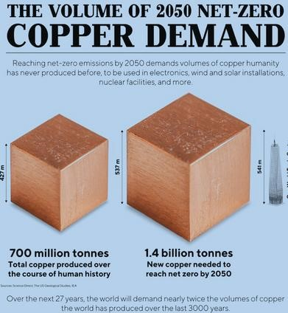The global demand for copper from renewable energy and technology industries is massive.

**Breaking the cycle:**

* ‘Seed investment’ in up-skilling, automation and mechanisation • Bring a professional and international dimension to the business
* Build expertise over time.

**Maximising value from the resources:**

* Local processing builds greater value per tonne
* Stop exploitation by international buyers by agreeing formal contracts.

**Unprecedented opportunity:**

* Tanzania holds 1.5% of global copper reserves
* Limited mining operations at present, but the Tanzanian Government is driving change.

## Our Vision

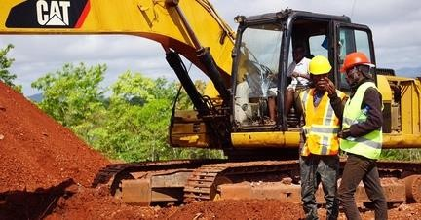To realise our dreams and ambitions and to make the mining operation a reality, together we have built a detailed business plan, which will establish the business on a firm operational and financial footing. See appendix 1 for details of our financial projections

By investing in new, high-quality machinery and mining-site infrastructure, without compromising on safety or quality, and by employing highly skilled miners, it will be possible to mine, crush, concentrate, transport and sell the copper ore quickly.

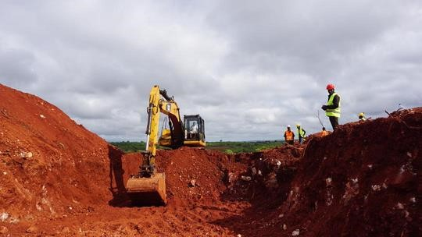Once the machinery is purchased and the mining operation set up it is a relatively simple task for the mining team to dig, crush and concentrate the copper ore, and send it to customers that are already contracted with us. Within six months we will begin building a copperconcentration plant to concentrate the ore into copper cathodes, which give us higher returns and we will follow this with extraction of other high-value metals such as gold and silver.

This is an opportunity for you to transform the lives of rural Mbesa townsfolk, by helping them to realise the true value of their land which contains abundant and highly valuable natural resources. Your investment in our business is forecast to deliver exceptional returns, with tax advantages for UK based investors through the venture capital SEIS & EIS scheme.

## Profitability Meets Purpose

Our mine will invest over $25m in:

* Elevating a poor rural mining community in Mbesa, Tanzania, to become wealthier, more-skilled and sustainably self-sufficient, including building and operating a farm so that local people can feed themselves
* Building critical infrastructure, including roads, a clinic, school classrooms, and a water purification plant, a modern, safe, clean, fully automated mine-site that will house at least 40 workers comfortably and employ many more
* Concentrating copper ore into pure copper cathodes, extracting precious metals and minerals, such as gold and silver, thereby maximising the return for the precious resources
* Investing in repairing local ecological systems and re-wilding the mine-site post-excavation.

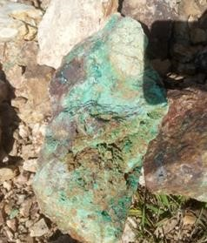While operating a profitable and sustainable business model with excellent ROI because we have:

* High-grade copper ore present in large quantities
* Mining licenses granted meaning we own the rights to mine the land and sell the ore
* Long-term customer contracts in place
* An experienced team in place and ready to start work.

## Our Mine Site

ASCL have been granted valuable, renewable mining licences by the Tanzanian Government which give them permission to mine precious metals and minerals across a specific area of around 220 acres in Mbesa. The mine area sits on the famous African copper-belt that runs across the continent and is the same one that delivers enormous wealth in DRC and Uganda, but it is so far largely unexploited within the borders of Tanzania.

Mineralisation - Typical Copper Concentrations

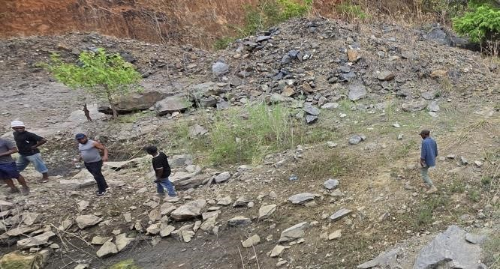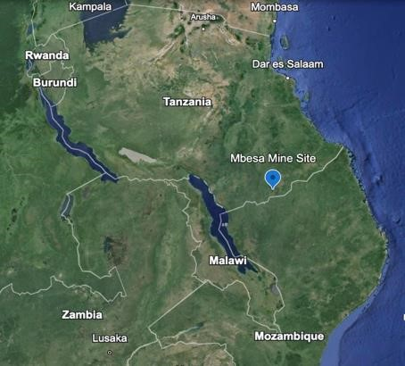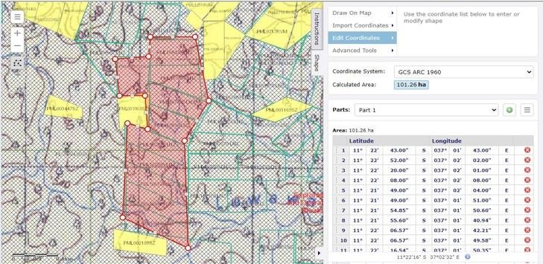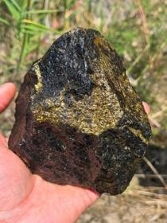

1. Chalcocite - 79.8%
2. Covellite - 66.4%
3. Bornite - 63.3%
4. Malachite - 57.5%
5. Azurite - 55.1%
6. Chalcopyrite - 34.6%
7. Tetrahedrite - 32.2%

**Key features:**

* Situated on the African Copper Belt, near Mbesa, Tunduru district
* Geological studies include visual inspection, geophysics resistivity analysis and shallow drilling
* Historical studies by Australian mining company, Redcliffe Mining, in 2014
* Surveys show the presence of malachite and azurite, at surface/pit level
* Local knowledge that we can mine ore consistently at 5% purity across the mine-site
* We will conduct further geological analysis to ensure that we mine the richest concentrations on the site.

## Approach

**"Scalable, Sustainable Solution"**

Madini Moyoni combines high-grade copper mining with social responsibility to transform Tanzania’s mining industry.

**Key Features:**

* Immediate impact, but building experience over time
* Profitability: Automated high-grade copper ore mining, copper concentration and precious metal extraction (gold, silver)
* Sustainability: Investments in schools, clinics, and clean water for local communities
* Scalability: A replicable model for expansion across Tanzania and Africa.

13

Phase 1

Mechanical Crushing, Sorting &

Grading

Phase 2

Copper Concentration

Phase 3

Precious Metal Extraction

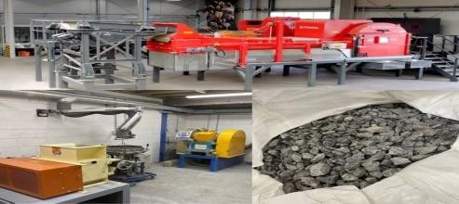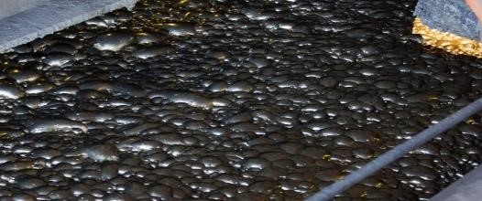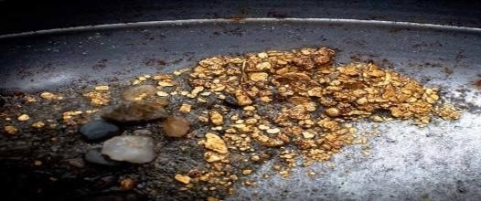

## Impact of Your Investment

**“Changing lives for the better” Social impact:**

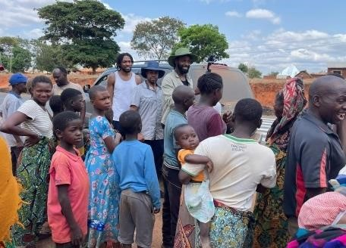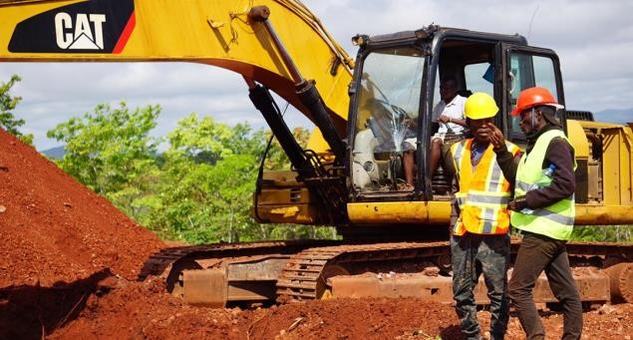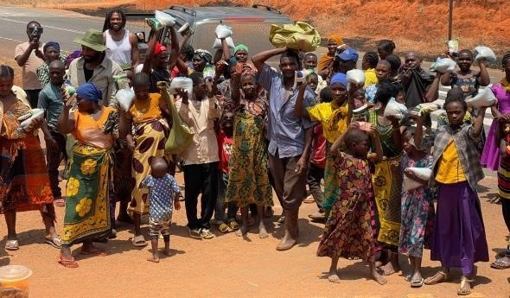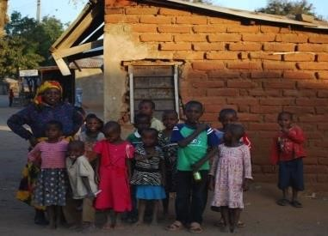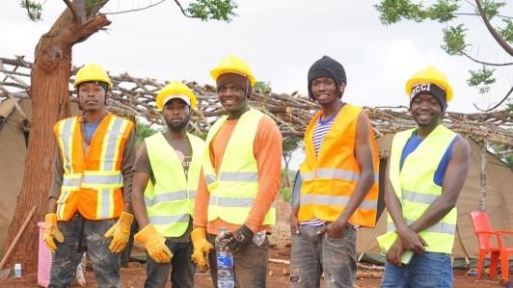

* Clean water, education, healthcare, roads and infrastructure.

**Job Creation and Economic Development:**

* **Direct Jobs:** Hundreds of opportunities in mining, logistics, and operations.
* **Indirect Impact:** Growth of local businesses (food, housing, transportation).
* **Skills Development:** Training programs to build a sustainable, skilled workforce
* **The Multiplier Effect:** Investment stimulates new businesses and uplifts livelihoods and the community.

**Environmental impact:**

* Ecological mine-site and follow-on farming support.

**Empowering Mbesa’s Workforce and Local Economy**

*One direct mining job will effectively impact the Workforce and Local Economy by a factor of 2.6X*

## What's in it for you? - SEIS Tax-relief for Investors

We have two strategic funding options for global investors 30% equity only and 20% Equity plus 8% (Gross Profit) in annual dividends Y2 onwards.

|  |  |  |  |
| --- | --- | --- | --- |
| MML-ASCL JV | Investment Returns  (Performance based and not guaranteed) | | |
| Equity Only (incl EIS) | Equity + % GP Dividend | SEIS Only |
| Equity Share | 30% | 20% | 3% |
| Dividends | N/A | 20% of profit share (8% GP) per annum | N/A |
| Exit (years) | 5+ | 5+ | 3+ |
| Minimum Investment | $100,000 | $50,000 | $50,000 |
| Investment Increments | $50,000 | $25,000 | $25,000 |
| Maximum Investment | $5,000,000 | $5,000,000 | $330,000 |
| Example Investment Period (Years) | 5 | 5 | 3 |
| Example Gross Investment | $5,000,000 | $5,000,000 | $330,000 |
| Example Total Dividends | N/A | $3,401,220 | N/A |
| Example Equity Exit Value | $24,359,560 | $16,239,707 | $1,966,488 |
| Example Total Return | $24,359,560 | $19,640,927 | $1,966,488 |
| Total X Return (ROI) | 4.9 | 3.9 | 6.0 |
| Example IRR | 37% | 34% | 81% |
| Notes: | •Equity granted in the form of  Common Shares  •End of Year 5 - Equity return  subject to trade sale, flotation or share buy-back  •UK EIS allows up to 30% rebate of investment and returns are tax free | •20% and up to 8% of gross profits as the annual dividend (Y2 onwards  •Equity granted in the form of  Convertible Preferred Shares  •End of Year 5 - Option to convert equity to cash, at fair market value, through share buy-back. | •$330k max investment total  •Equity granted in the form of  Common Shares  •End of Year 3 - Equity return  subject to trade sale, flotation or share buy-back  •UK SEIS allows up to 50% rebate of investment and returns are tax free. |

April 2025

Madini Moyon i

What you get for investment:



At Madini Moyoni, we believe that investment means more than financial returns — it's about creating lasting impact.



Through your partnership, you have the opportunity not just to fuel our growth, but to help shape communities, build futures, and leave a legacy of real change.

We've designed a range of investment tiers to recognise and celebrate our supporters at every level — offering exclusive benefits, access to real-world impact, and opportunities to have your name honoured across our social initiatives.

|  |  |  |  |
| --- | --- | --- | --- |
| **TIER 1: Pathfinder - £5k** | **TIER 2: Trailblazer —**  **£10K** | **TIER 3: Visionary — £20K** | **TIER 4: Architect — £50K** |
| Every great journey begins with a single step. You help lay the foundation stones of a bigger future. | Leading the way, lighting the path for others. Your support pushes innovation and access forward. | See beyond — invest in dreams becoming reality. Your name will live on in every life your impact touches. | Building the future, one foundation at a time.  You don't just invest — you leave a legacy. Change the world. Leave your mark for generations. Your name will stand at the heart of progress. |
| Benefits:   * Digital Certificate of Investment * Early access to product launches or services * Quarterly personalised investor updates * 5% discount on products/ services * Recognition in the company's online   “Investor Wall of  Honour” | Benefits:   * All Pathfinder benefits, plus: * Invitation to an exclusive annual investor webinar with founders * 10% discount on products/ services * Option to have your name or company name honoured on a social project (school, clinic, well, etc.) | Benefits:   * All Trailblazer benefits, plus: * Invitation to visit one of the funded social projects (special hosted tour) * Detailed impact reports every 6 months showing project progress * Annual video call showing you the impact of your investment on the ground. * Private networking session with leadership annually * Option for partial project naming rights (e.g., "The   [YOUR Name] Learning Center  Classroom") | Benefits:   * All Visionary benefits, plus: * Priority access to new funding rounds * 15% discount on company products/services * Limited-edition merchandise or commemorative gift * Exclusive quarterly briefings on company strategy and major milestones * Personal planning session with executives yearly * Optional advisory or board observer role * Full naming rights on major projects (e.g., entire school building, library, clinic, etc.) * VIP Access to all major events (openings, celebrations, investor retreats) |

## Join Us

**"Be Part of a Movement That Matters"**

**Summary:**

* Madini Moyoni combines profitability with purpose, offering a scalable, socially responsible mining operation with strong financial returns.
* Join us in transforming Tanzania’s mining industry and creating lasting impact.

**Call to action:**

Invest now – contact us info@madinimoyoni.co.uk; WhatsApp: +447931657472;

**Next steps:**



**Month 1**

•

Apply funding

•

Implement corporate structures

•

Build operational plan

•

Procure heavy equipment

•

Build mine

-

site accommodation

•

Build local infrastructure.

**Month 2**

•

Start social projects.

•

Start building community clinic

•

Implement compliance and safety

standards

•

Begin mining Copper ore

•

Sign additional customer contracts.

•

Optimise

operations

•

Upscale volumes mined

•

Plan future social projects.

**Month 3**

## Our website

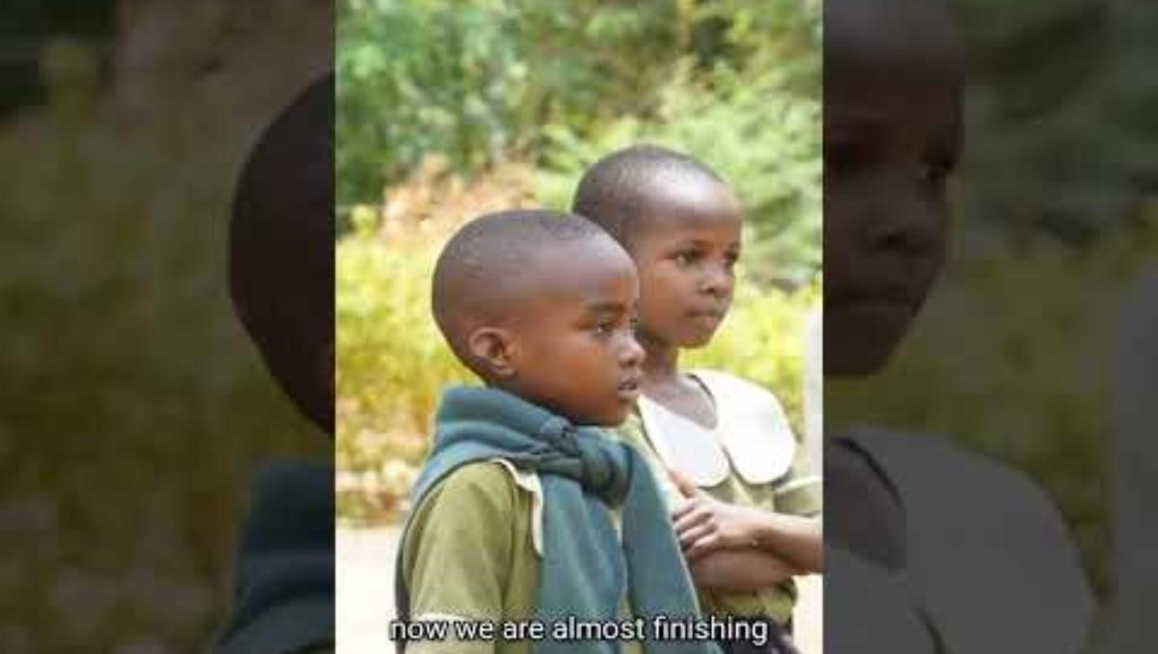

[www.madinimoyoni.co.uk](http://www.madinimoyoni.co.uk/)

***"If real development is to take place, the people have to be involved."***

Julius Kambarage Nyerere, from his book Uhuru na Maendeleo (Freedom and Development), 1973.

## Appendix I: Financial Projections & Market Capitalisation

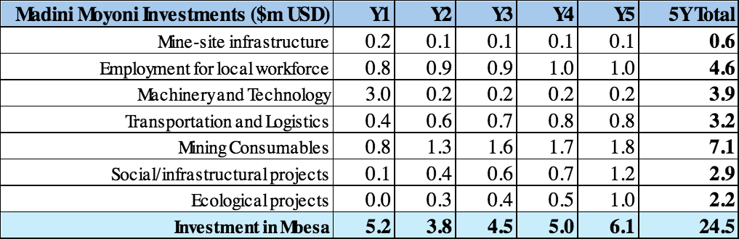

19

## Appendix II: Investment Breakdown



20

## Appendix III: High Level Risks

|  |  |
| --- | --- |
| **Risk** | **Mitigation** |
| Copper ore purity too low | Mechanical sorting will allow us to process quickly the high quantities of 4-5% purity ore that we know pervades the African Copper Belt, rather than having to chase copper seams; we will invest in additional geological surveys early on to drive the most efficient mining plan. |
| Can not operate mine efficiently | Mechanical sorting will allow us to process quickly the high quantities of 4-5% purity ore that we know pervades the African Copper Belt, rather than having to chase copper seams; we will have mining experts on-site to project manage and train ASCL personnel in using the advanced machinery and setting up the mine |
| The Rainy Season(s) | We will build roads linking the mine-site to the main road, construct hard-standing areas for vehicles to move freely on-site, invest in dewatering systems (pumps and irrigation), a covered warehouse for stockpiling ore for processing undercover during the rains. |
| Machinery and equipment failure | We have a ‘fail-over’ capability in place for heavy plant and machinery, by operating two of most of the vehicles, plus we will have an on-site repair capability. |
| Health and Safety | We will employ a consultant with a track record of working with mining corporations worldwide and knowledge of standards in Europe &other highly industrialised countries, and we will carry out regular audits and risk assessments. |
| Shortage of mining consumables | We will stockpile fuel on-site in fuel tanks to cover short term unavailability |
| Theft and security | We will engage a trusted transportation agent and clearing agent, plus invest in the technology and personnel to ensure that we have a secure mine-site and supply chain. |
| Not delivering socio-economic benefits | We will appoint a village elder as a Trustee to ensure funds are allocated for intended purposes and that the local community is at the heart of our local social, economic and infrastructural projects’ decision-making processes |

21

Appendix IV: Madini Moyon i



## ESG (Environmental, Social, Governance) Road Map

**Today: Foundation Phase (2025)**



|  |  |  |
| --- | --- | --- |
| **Area** | **Action** | **Target Date** |
| **Environmental Certification** | Align with ISO 14001 (Environmental Management Systems) | 2026 |
| **Responsible Mining Certification** | Fairmined Certification (ARM / Fairtrade Africa) | 2027 |
| **Climate Action** | Carbon footprint baseline & reduction targets | 2026 |
| **Local Partnerships** | Formal MOU with NGOs (e.g., LEAT, WWF Tanzania) | 2025 |
| **ESG Reporting** | Publish first Sustainability Impact Report | 2026 |

**Next 12–24 Months: Growth Phase (2025–2027)**

|  |  |  |
| --- | --- | --- |
| **Area** | **Action** | **Status** |
| **Environmental Compliance** | NEMC EIA Submission & Approval | In Progress |
| **Mining Regulation Compliance** | Tanzania Mining Commission Standards | In Progress |
| **Community Engagement** | Baseline Community Programs (water, schools) | Launched |
| **Responsible Sourcing** | Initial ASM Code of Practice Adoption | Initiated |

Vision: 2027 and Beyond

Become a model for sustainable mining across Tanzania.

Drive circular economy practices by investing in local copper processing and reforestation projects.

Establish a Community Development Fund reinvesting profits into roads, education, healthcare, and clean energy projects.

22

*Building a better future responsibly, transparently, and sustainably.*